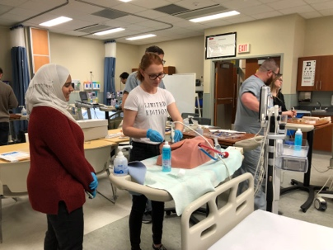
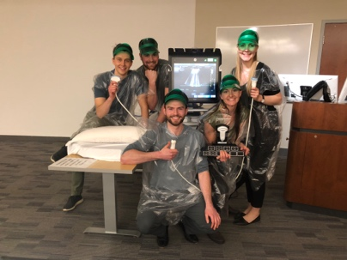
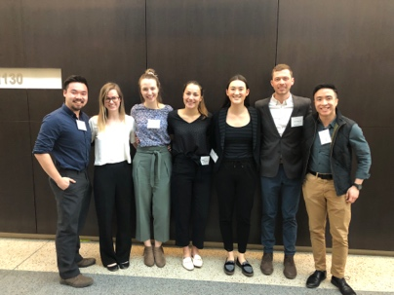
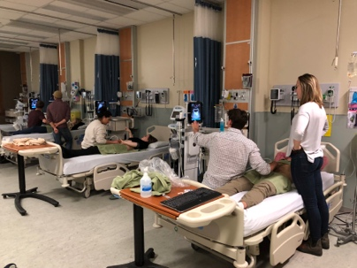

University of Saskatchewan Ultrasound (USUS)
2018-2019 Update

It was another scantastic year for the U of S Ultrasound group!
As a student group, our primary goal is to provide opportunities for medical students to develop skills in point-of-care ultrasound and learn to integrate ultrasound findings into clinical decision-making. Over the 2018-2019 academic year, these opportunities included thirteen hands-on scan nights across both Saskatoon and Regina sites, incorporating the EchoLog app for students to keep track of their scans, a panel discussion about elective opportunities in ultrasound, and the fourth annual SASKSONO conference!
The year started off strong in Saskatoon, with our first scan night taking place in September for nearly sixty excited students who were keen to get an early start in developing their ultrasound skills! This was followed by monthly hands-on events, with a main focus on point-of-care ultrasound techniques particularly applicable to emergency medicine. Our later scan nights involved collaboration with other student groups and medical specialties, with the goal of highlighting the diverse applications of ultrasonography in clinical practice; this included an event in collaboration with internal medicine that combined both clinical and ultrasound skills for assessment of volume status, a scan night with the Obstetrics & Gynecology Interest Group during the reproductive medicine unit of our academic curriculum, and a hands-on venous access session taught through collaboration with the Anesthesia Interest Group. At the Regina site, further scan nights focused on skills relevant to our course-based learning, including topics relating to nephrology, urology, and musculoskeletal imaging. Throughout these events, students were able to keep track of their scans using the exciting new EchoLog app, thanks to the generous support of Sasksonic in funding the app for our students. In all, these scan nights provided opportunities for over one hundred students to practice hands-on skills that complemented our cutting-edge ultrasound curriculum here at the U of S College of Medicine.
An additional initiative taken on by U of S Ultrasound this year was to promote continued experiences with point-of-care ultrasound throughout clerkship training. Here at the U of S, we are fortunate to have the Clinical Ultrasound Elective in Clerkship (CUSEC), so we organized an information session and panel discussion to provide students with guidance regarding this exciting opportunity that is available within our College. Throughout all of our events, we have observed such enthusiasm among our students, so we look forward to seeing this excitement continue and grow over the years!
The annual SASKSONO Ultrasound Symposium took place on March 2, and the U of S Ultrasound group would like to thank the College of Medicine Alumni Association, Saskdocs, and Sasksonic for their support of this event. The help of these generous donors facilitated a high level of involvement in the conference by allowing student registration costs to be reduced, thereby increasing the accessibility of this unique opportunity for all students. The SASKSONO19 event was certainly another one to be remembered, with an exciting program that offered a deep dive into the world of ultrasound! The day was filled with engaging keynote presentations on emergency and pediatric ultrasound, concurrent sessions for students to learn about ultrasound applications in gastroenterology and practice hands-on skills through supervised scanning, lighting oral abstracts that highlighted point-of-care ultrasound as a rapidly-growing field of research, and the SONOlympiad competition for students and residents to show off their skills!
Overall, the U of S Ultrasound group had another exciting and busy year of events, and we look forward to many more to come! Thank you all for your ongoing support!

